Project Name: Automation Exercise
Module:User Authentication & Shopping (Login, Registration, Product Search, Cart, Checkout, Payment & Logout)
Testing Type: Manual Testing
Webpage URL: https://www.automationexercise.com/

● Scenario ID: 1a
Scenario: Open Automation Exercise
Test Steps:
Open Automation Exercise website

Screenshots:


● Scenario ID: 1a
Scenario: Open Login Page
Test Steps:
Click Signup/Login

Screenshots:
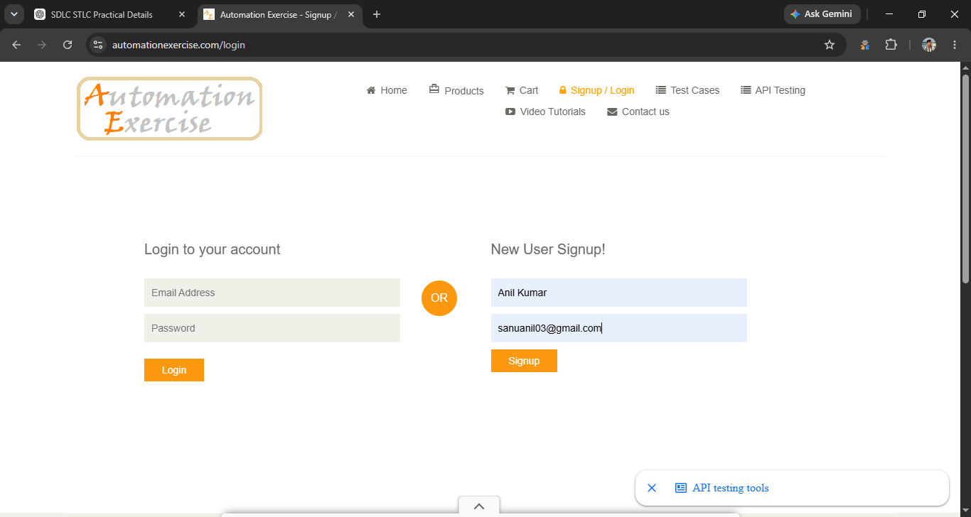

● Scenario ID: 2a
Scenario: Register New Account
Test Steps:
Register a new account

Screenshots:
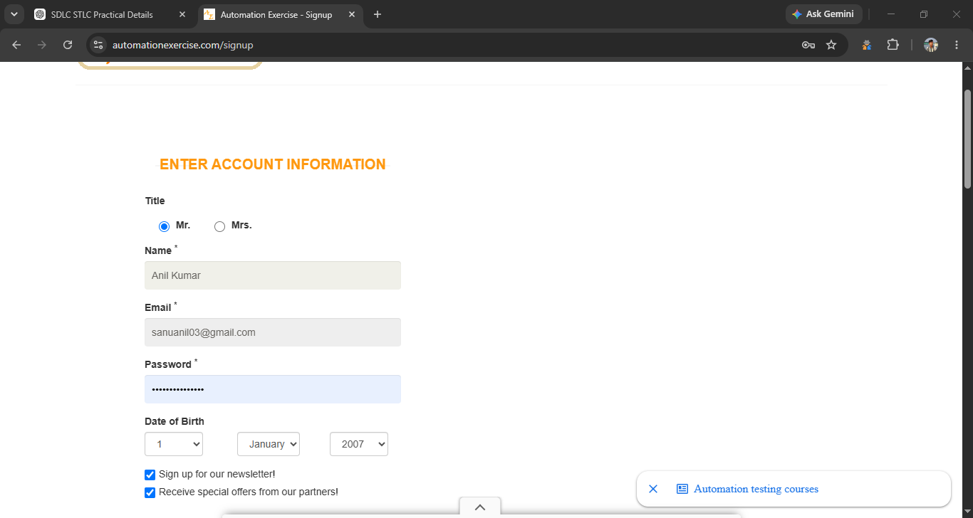
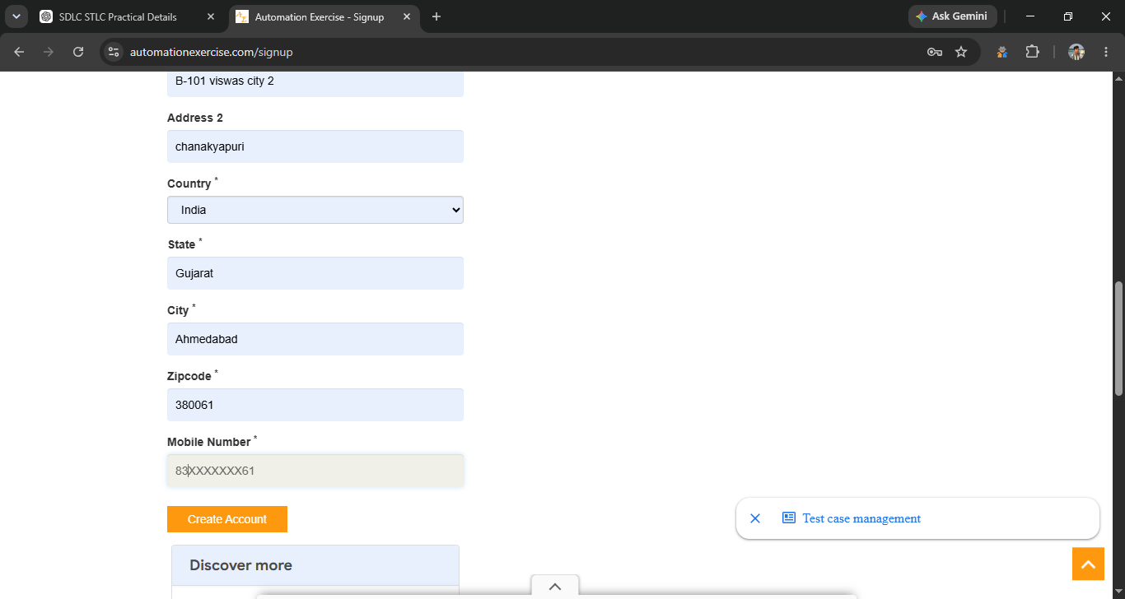

● Scenario ID: 2b
Scenario: Login with Valid Credentials
Test Steps:
Enter valid email & password and click Login

Screenshots:


● Scenario ID: 3a
Scenario: Search Product
Test Steps:
Search for a product

Screenshots:


● Scenario ID: 3b
Scenario: Add Product to Cart
Test Steps:
Click Add to Cart

Screenshots:


● Scenario ID: 4a
Scenario: View Shopping Cart
Test Steps:
Open shopping cart

Screenshots:
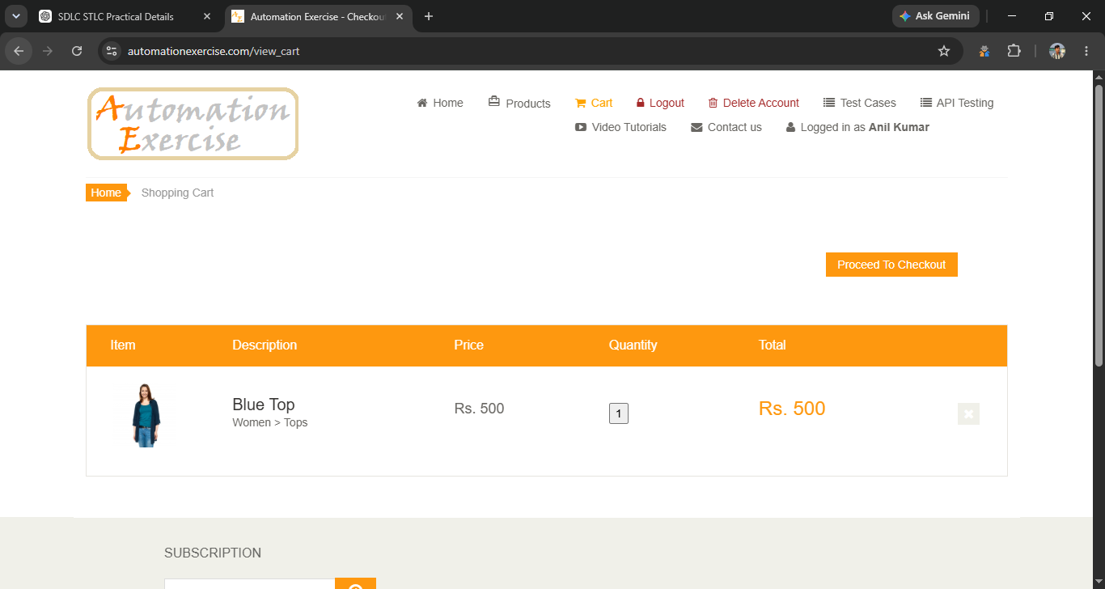

● Scenario ID: 4b
Scenario: Update Product Quantity
Test Steps:
Change quantity to 2

Screenshots:
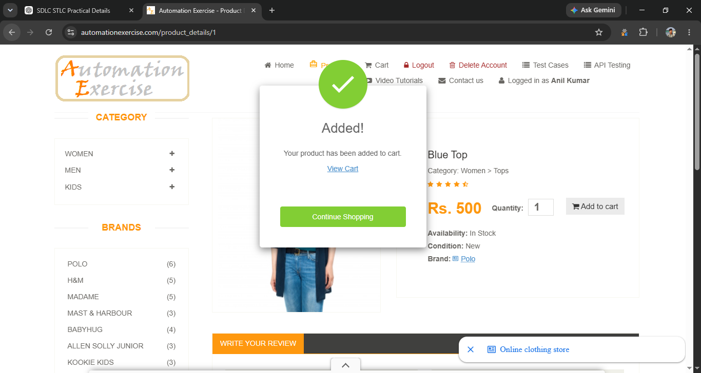

● Scenario ID: 5a
Scenario: Proceed to Checkout
Test Steps:
Click Proceed to Checkout

Screenshots:
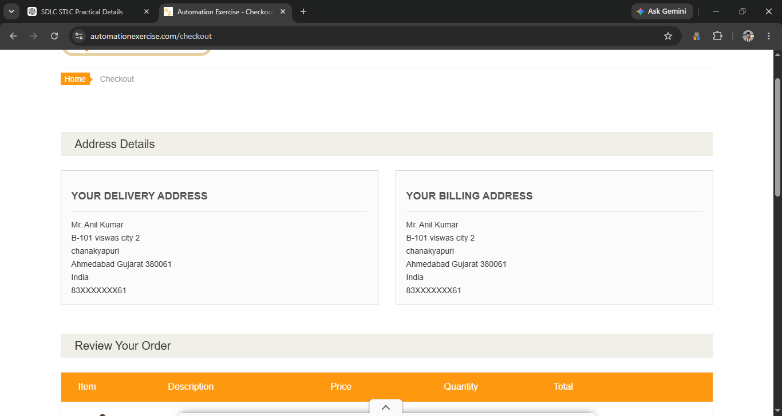

● Scenario ID: 6a
Scenario: Enter Payment Details
Test Steps:
Fill payment form

Screenshots:
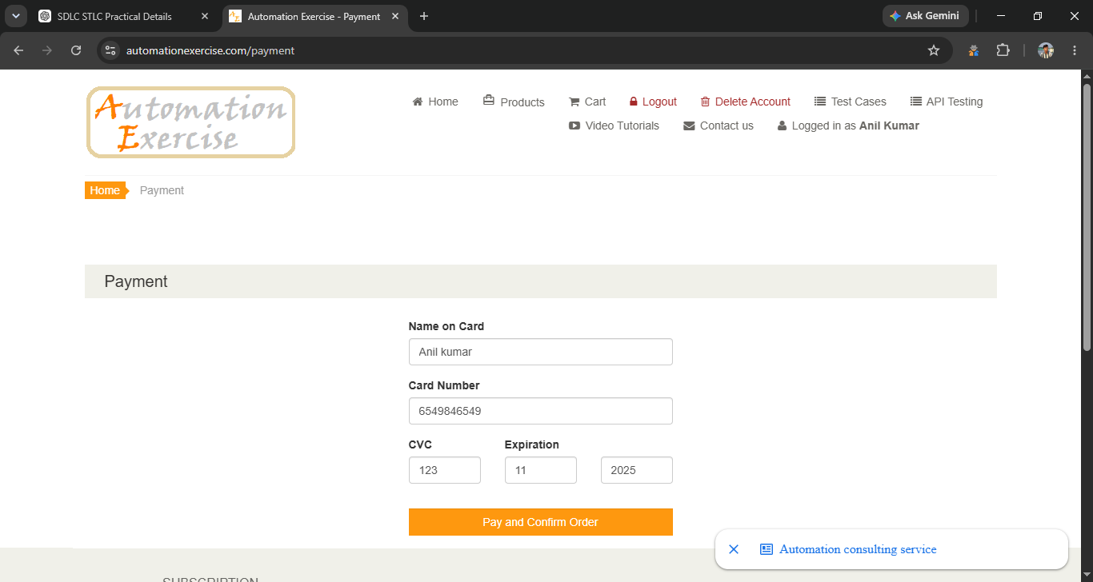

● Scenario ID: 7a
Scenario: Logout
Test Steps:
Click Logout

Screenshots:


Summary of Test Results
- Total Test Cases: 19
- Passed: 18
- Failed: 1
- Pass %: 94.74%

● Conclusion and Recommendations
Pass Rate: 94.74% – Application Performs Well with Minor Improvements Required
The Automation Exercise web application successfully passed most of the functional test scenarios covering website access, registration, login, product search, cart operations, checkout, payment, order confirmation, invoice download, logout, and invalid login validation.
The overall pass rate of 94.74% indicates that the application is functioning effectively, with only a minor issue identified in the product quantity update functionality.

● Issues Found

1. Product Quantity Not Updated in Cart (4b)
When the quantity of the selected product was changed to 2 in the Shopping Cart, the product quantity was not updated as expected.
Expected Result:
The product quantity should be successfully updated to 2.
Actual Result:
The product quantity was not updated.
Status: Failed

● Recommendations

1. Fix Cart Quantity Update Functionality
Ensure that the Shopping Cart correctly processes and reflects changes made to the product quantity.

2. Improve Cart Synchronization
Verify that quantity changes are properly synchronized between the cart interface and the underlying cart data so that the updated quantity is displayed immediately.

3. Perform Regression Testing
After fixing the quantity update defect, perform regression testing on the complete Cart and Checkout modules to ensure that the correction does not affect other shopping and order-related functionalities.

